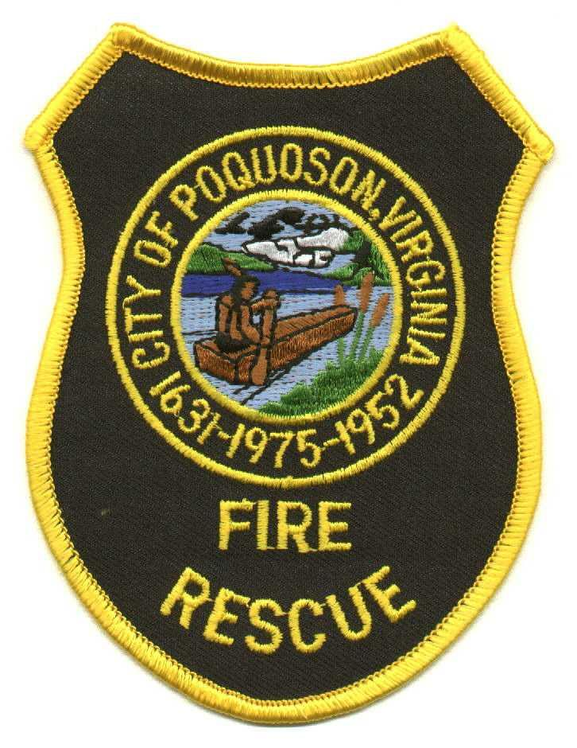

City of Poquoson Fire/Rescue
101 City Hall Avenue, Poquoson, Virginia 23662 (757) 868-3510 Fax (757) 868-3514

Summary

- Consolidated GA 9.00 (Training and Weather Conditions), GA 9.10 (Training Administration), and GA 9.11 (Reporting of Off-Site Training) into one document.

- Updated references to NFPA 1584, OSHA bloodborne pathogens, and NIMS requirements.

- Clarified responsibilities by rank.

- Clarified temperature thresholds for training.

- Required electronic documentation rather than paper hard copies.

- Clearly defined physical training as being separate from company training.

- Made many formatting and some spelling corrections.

